**SCREENSHOTS**

**4. Steps By Step Process**

1. **Create an EC2 instance**

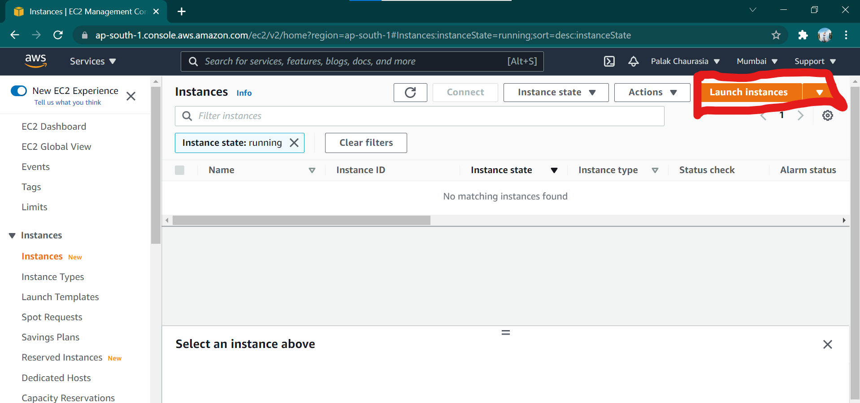

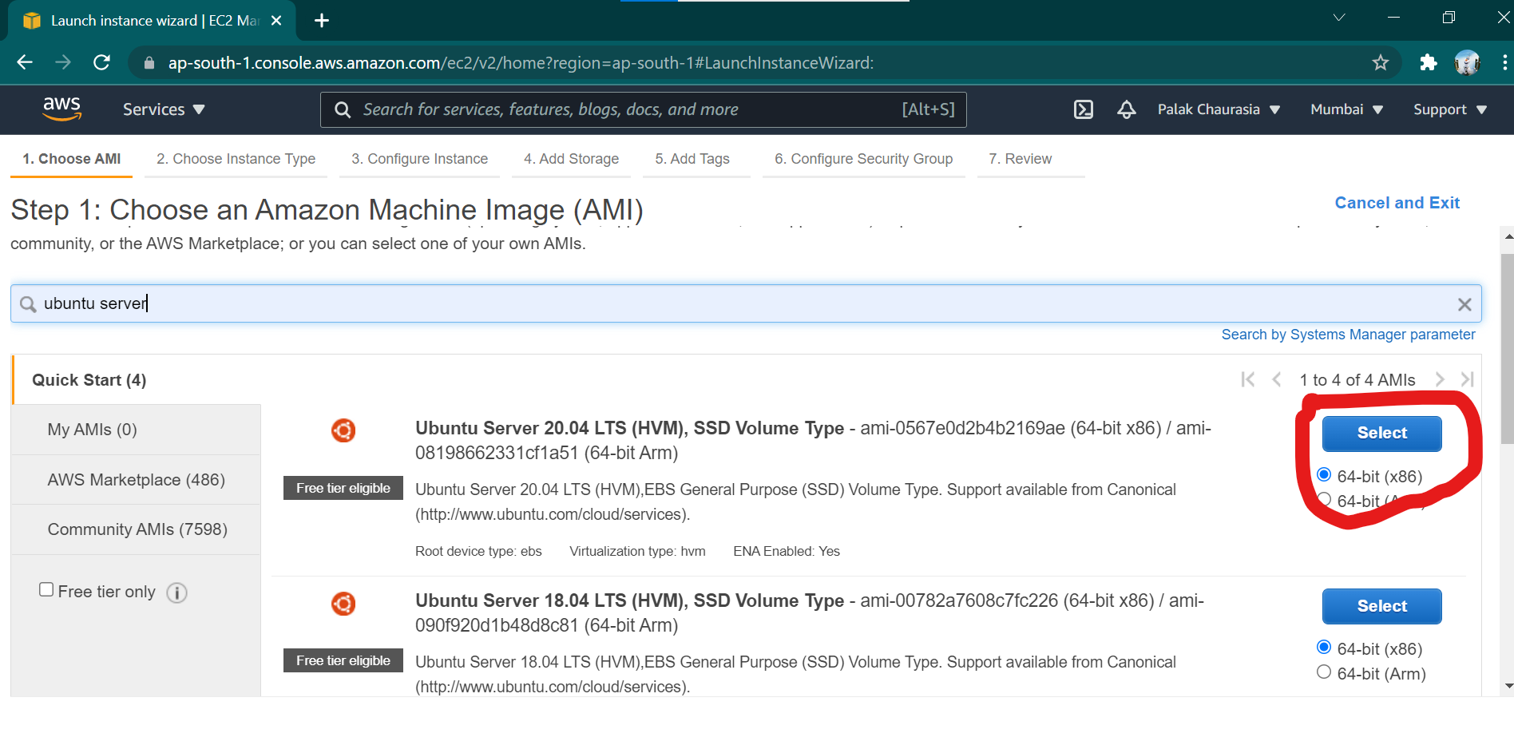

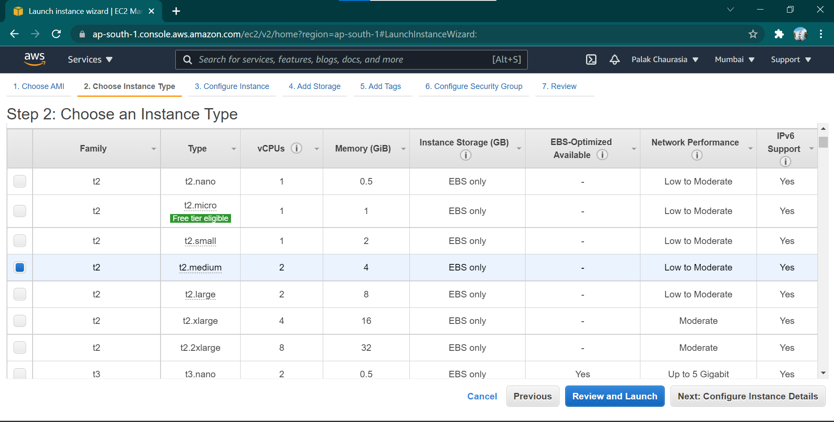

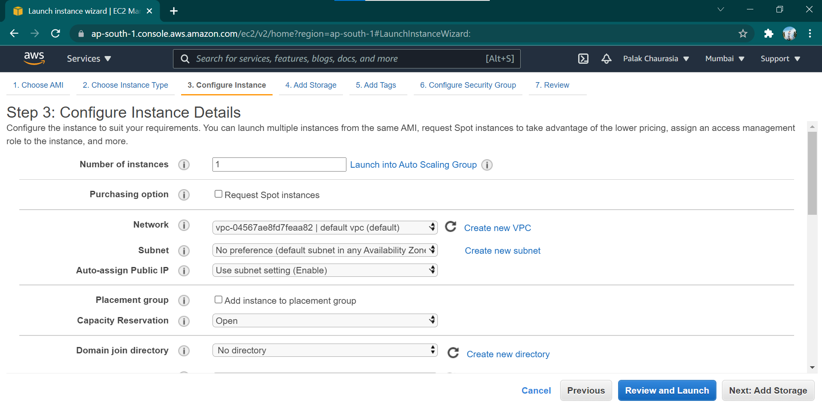

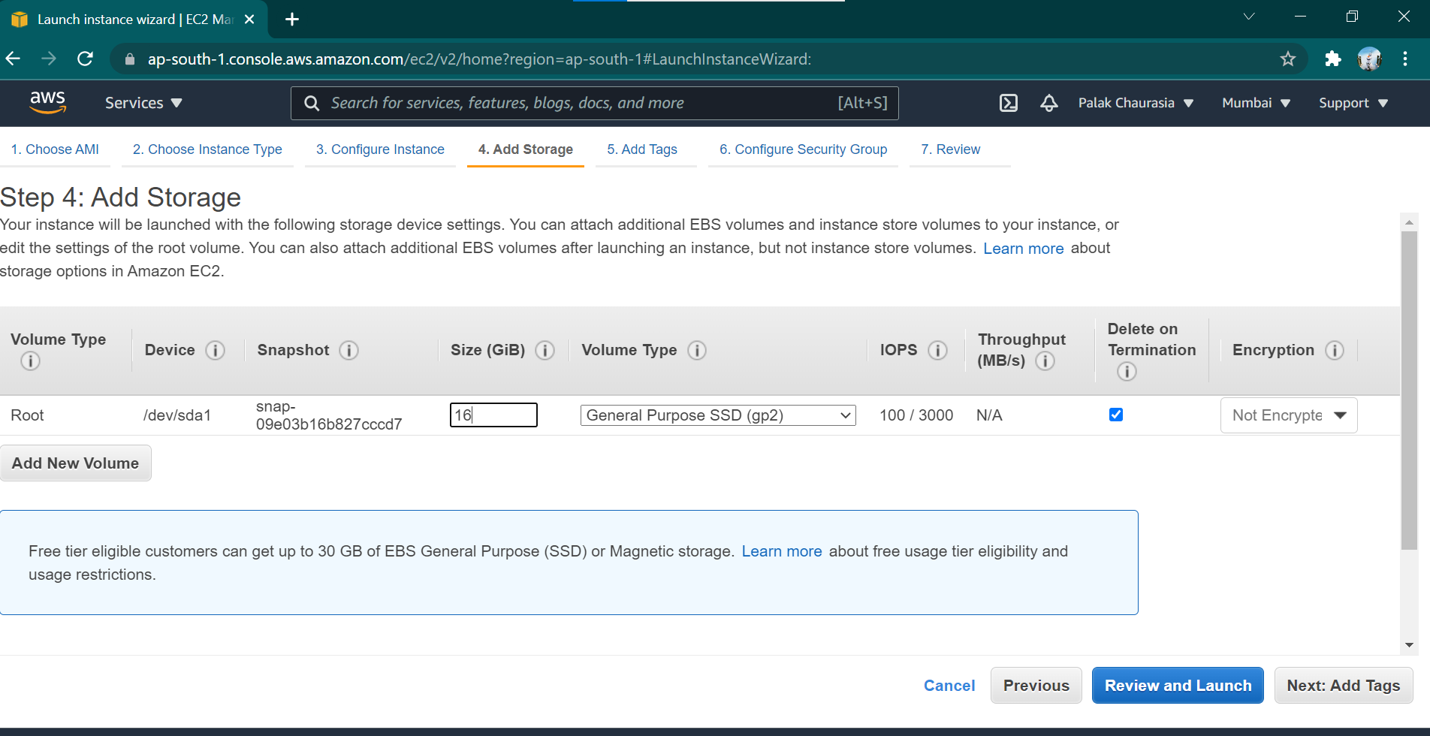

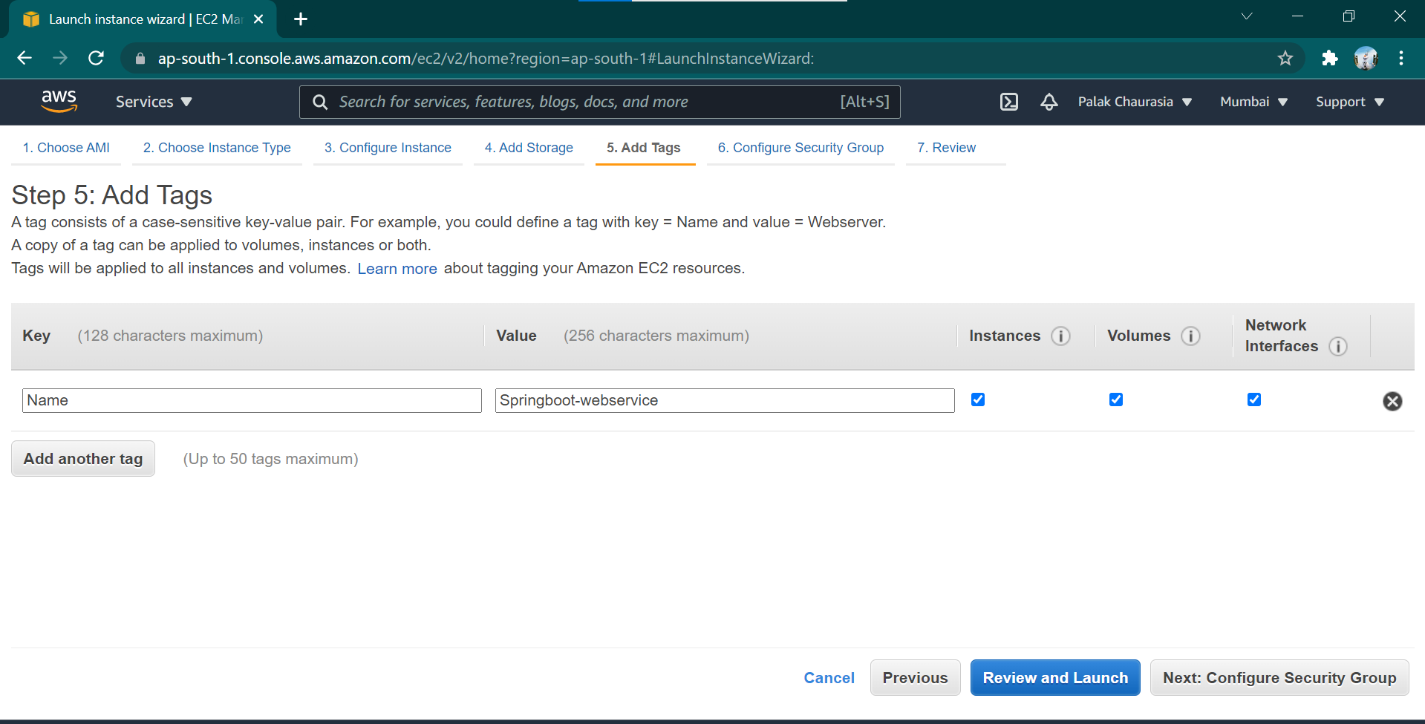

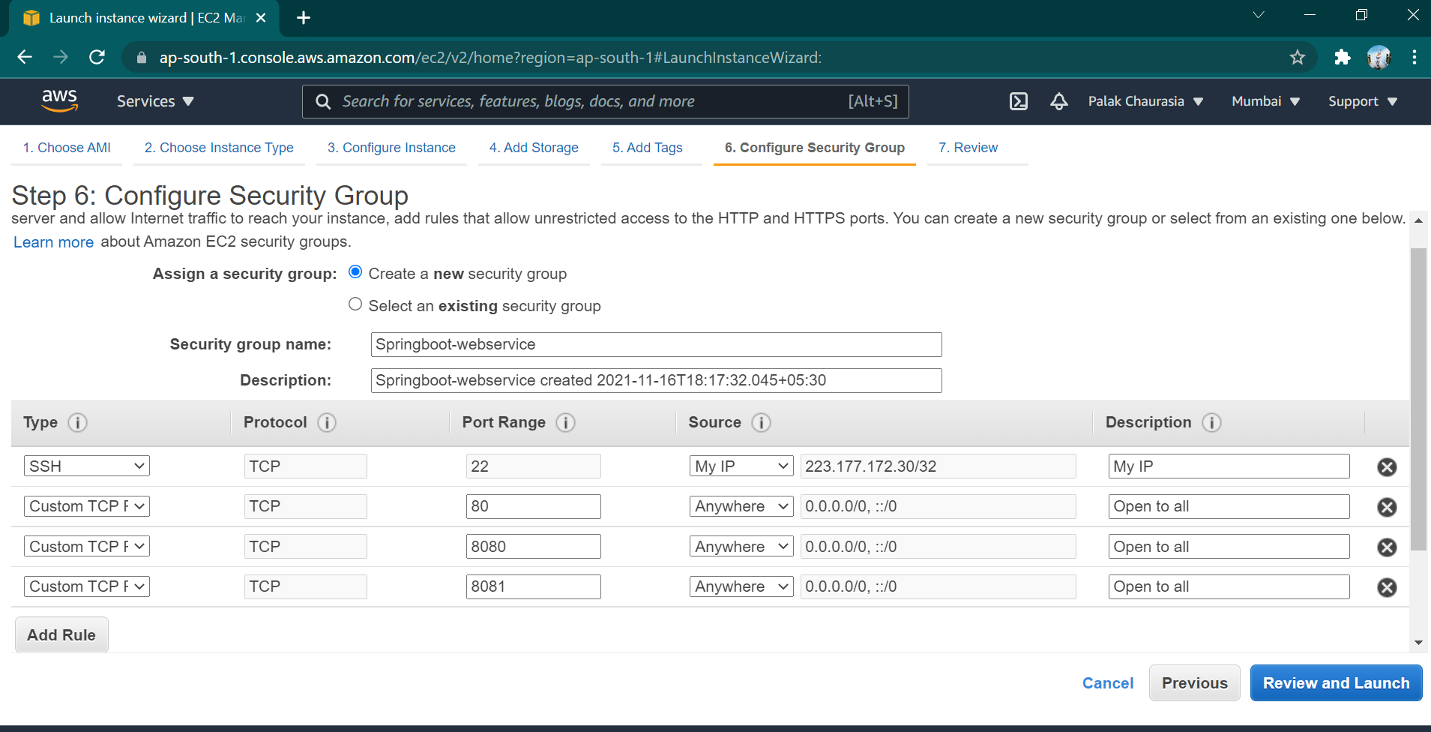

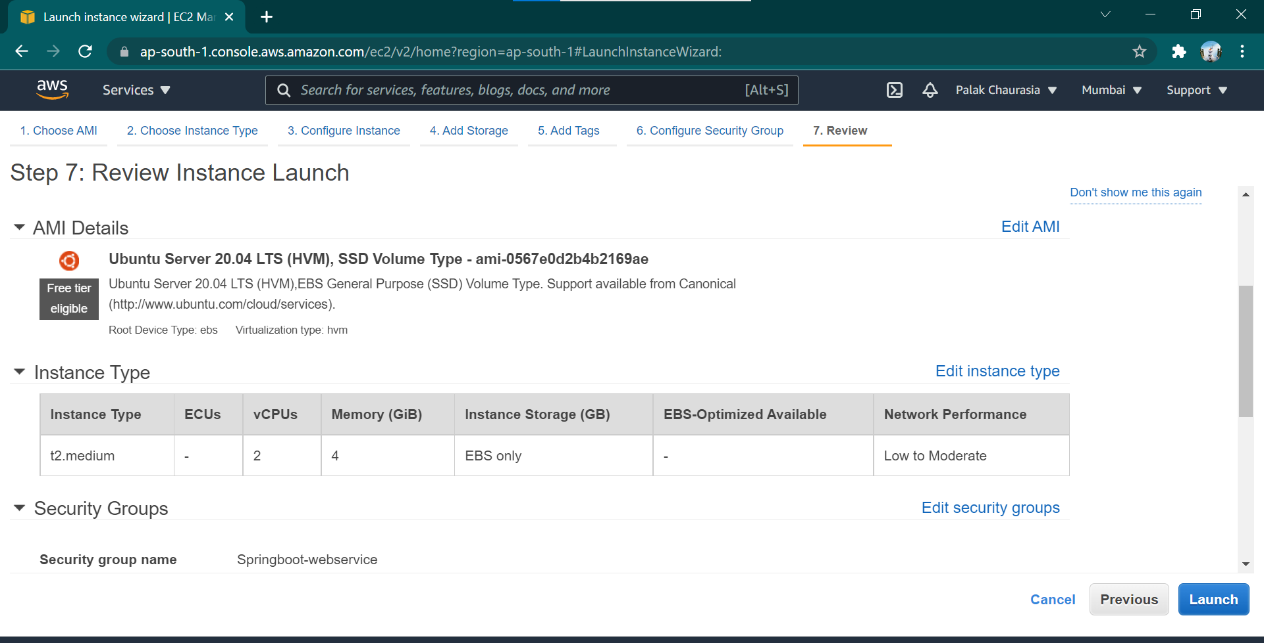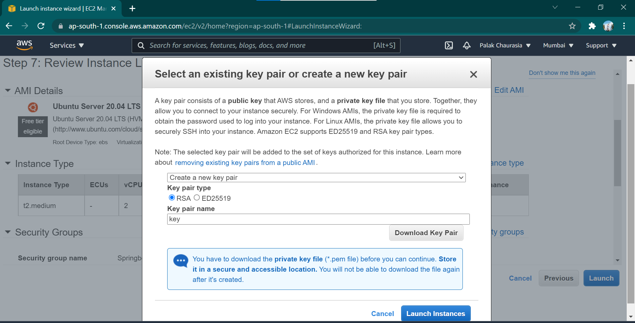

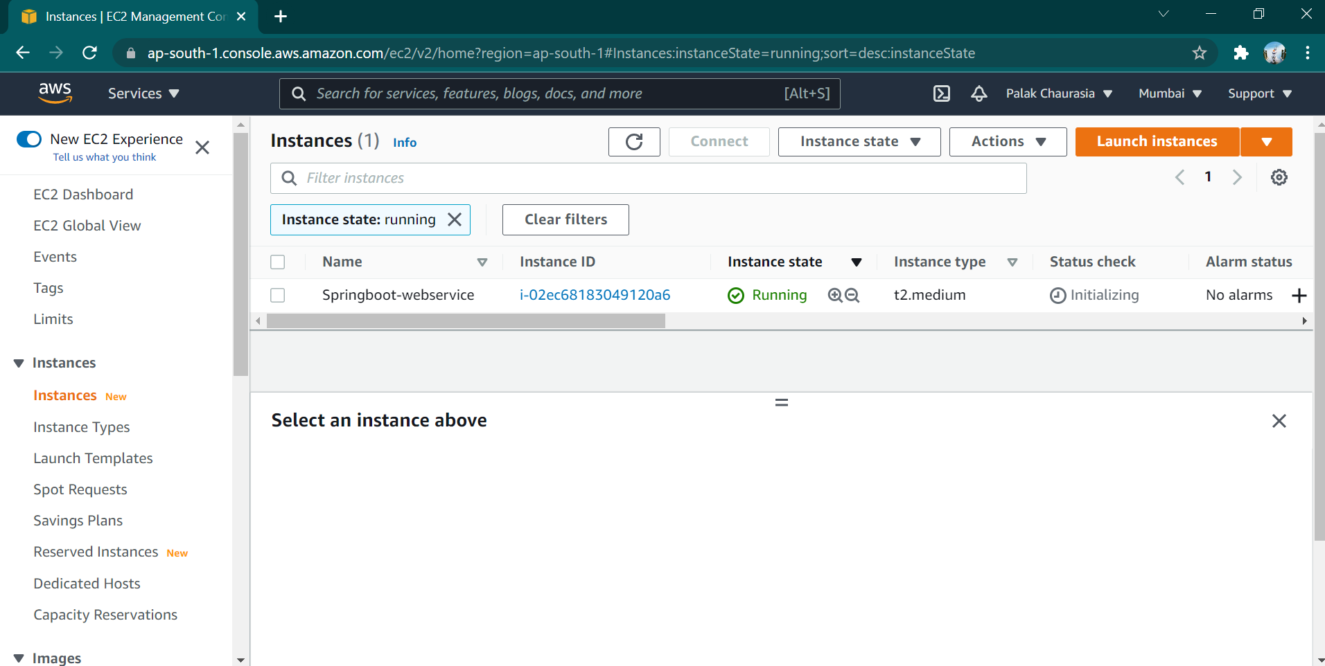

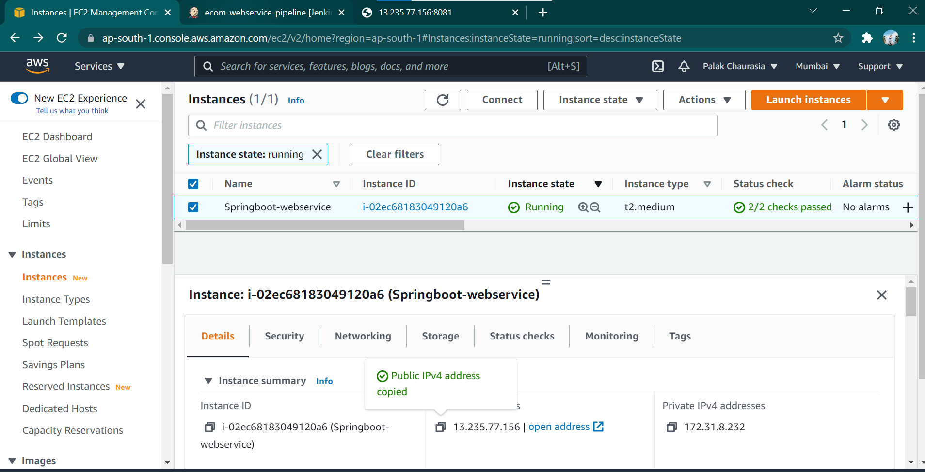

1. **Connect to EC2 Instance**

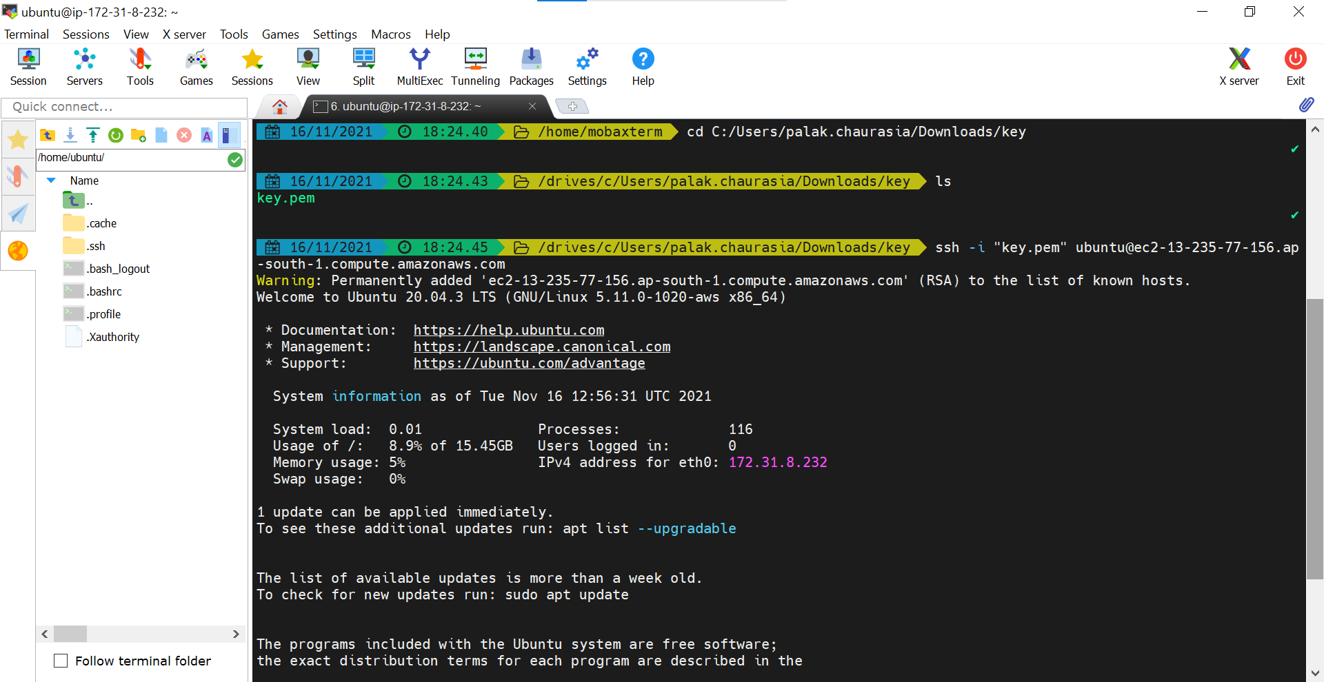

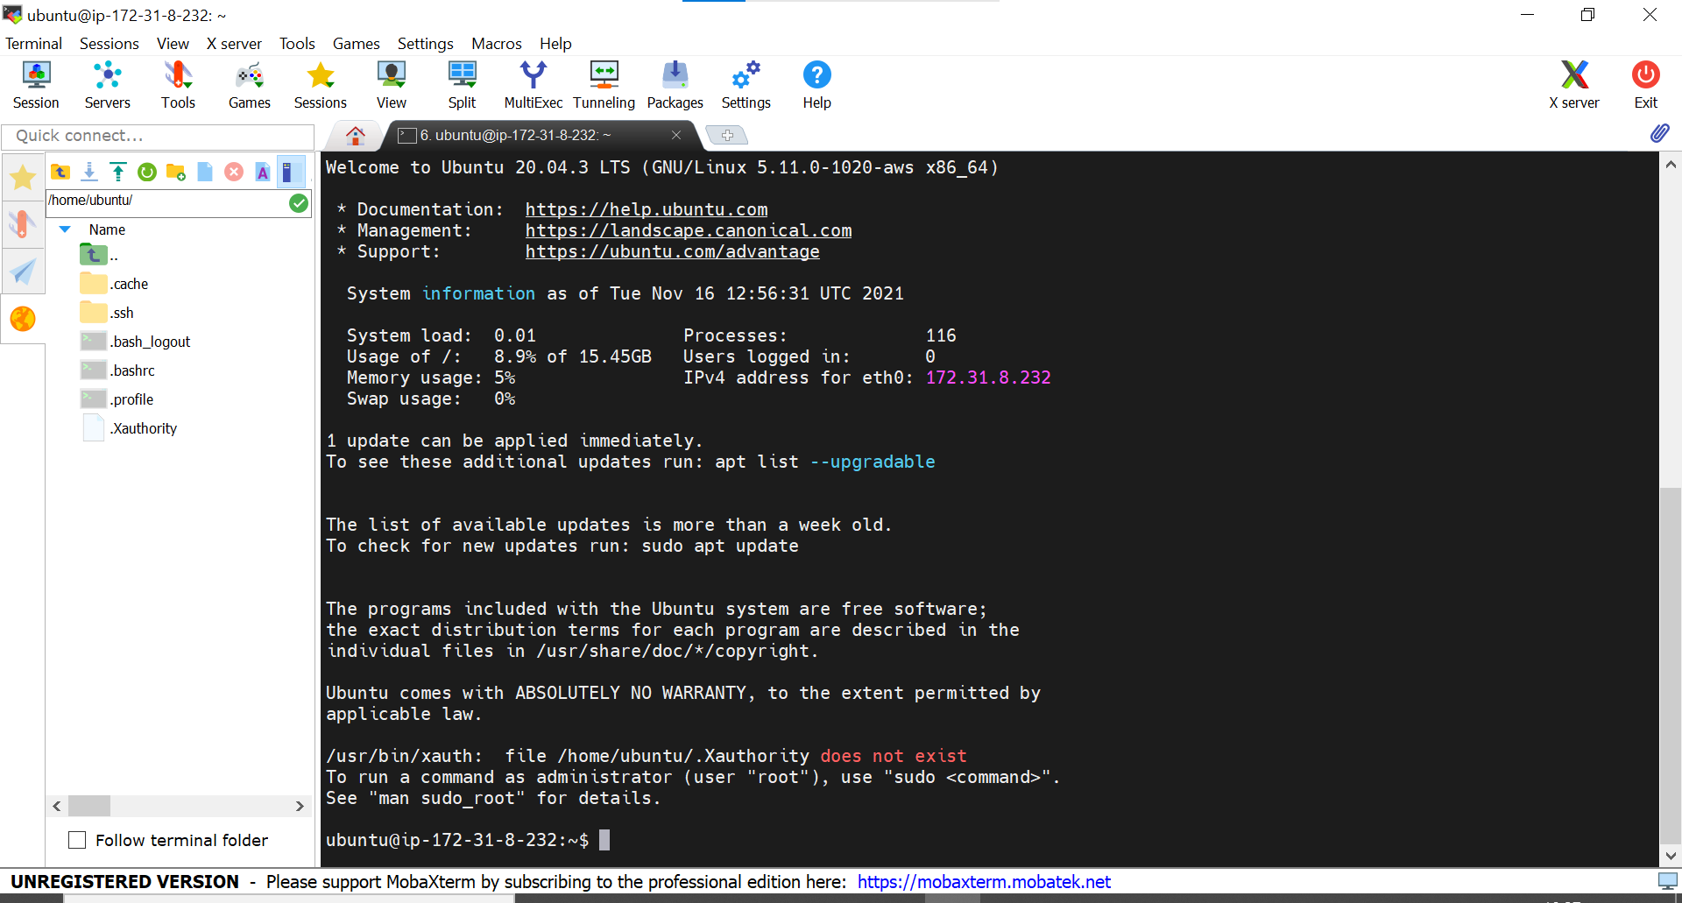

1. **Install Docker on Ubuntu Instance**

Using these commands

* sudo apt –get update
* sudo apt-get install ca-certificates curl gnupg lsb-release -y
* curl-fsSL https://download.docker.com/linux/ubuntu/gpg | sudo gpg --dearmor -o /usr/share/keyrings/docker-archive-keyring.gpg
* echo "deb [arch=$(dpkg --print-architecture) signed-by=/usr/share/keyrings/docker-archive-keyring.gpg] https://download.docker.com/linux/ubuntu $(lsb_release -cs) stable" | sudo tee /etc/apt/sources.list.d/docker.list > /dev/null
* sudo apt-get update
* sudo apt-get install docker-ce docker-ce-cli containerd.io –y
* sudo docker –v

1. **Docker pull images**

Using these commands

* sudo docker pull Ubuntu
* sudo docker pull mysql
* sudo docker pull alpine
* sudo docker pull openjdk
* sudo docker images

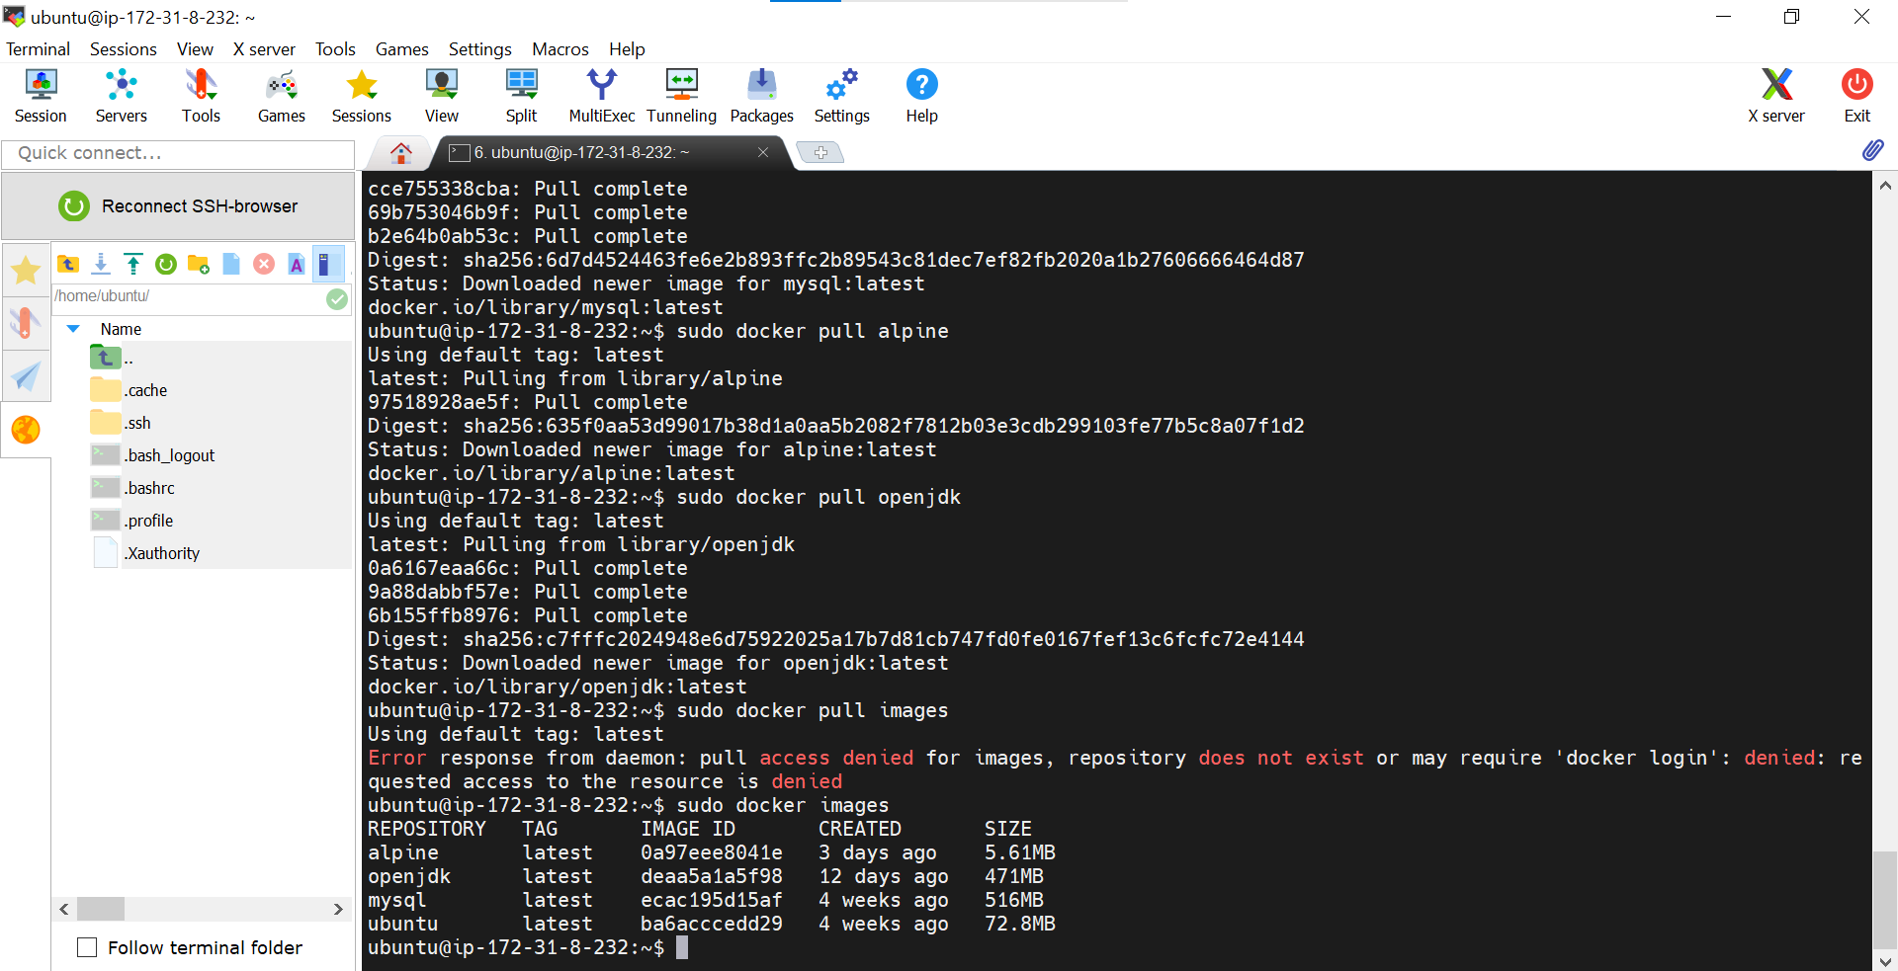

1. **Install JDK, Maven, Sql on Instance**

Using these commands

* sudo apt install default-jdk –y
* sudo apt install maven –y
* sudo apt install mysql-server -y

1. **Install Jenkins**

Using these commands

* wget -q -O - https://pkg.jenkins.io/debian-stable/jenkins.io.key | sudo apt-key add –
* sudo sh -c 'echo deb https://pkg.jenkins.io/debian-stable binary/ > /etc/apt/sources.list.d/jenkins.list'
* sudo apt-get update
* sudo apt-get install Jenkins
* sudo service jenkins status

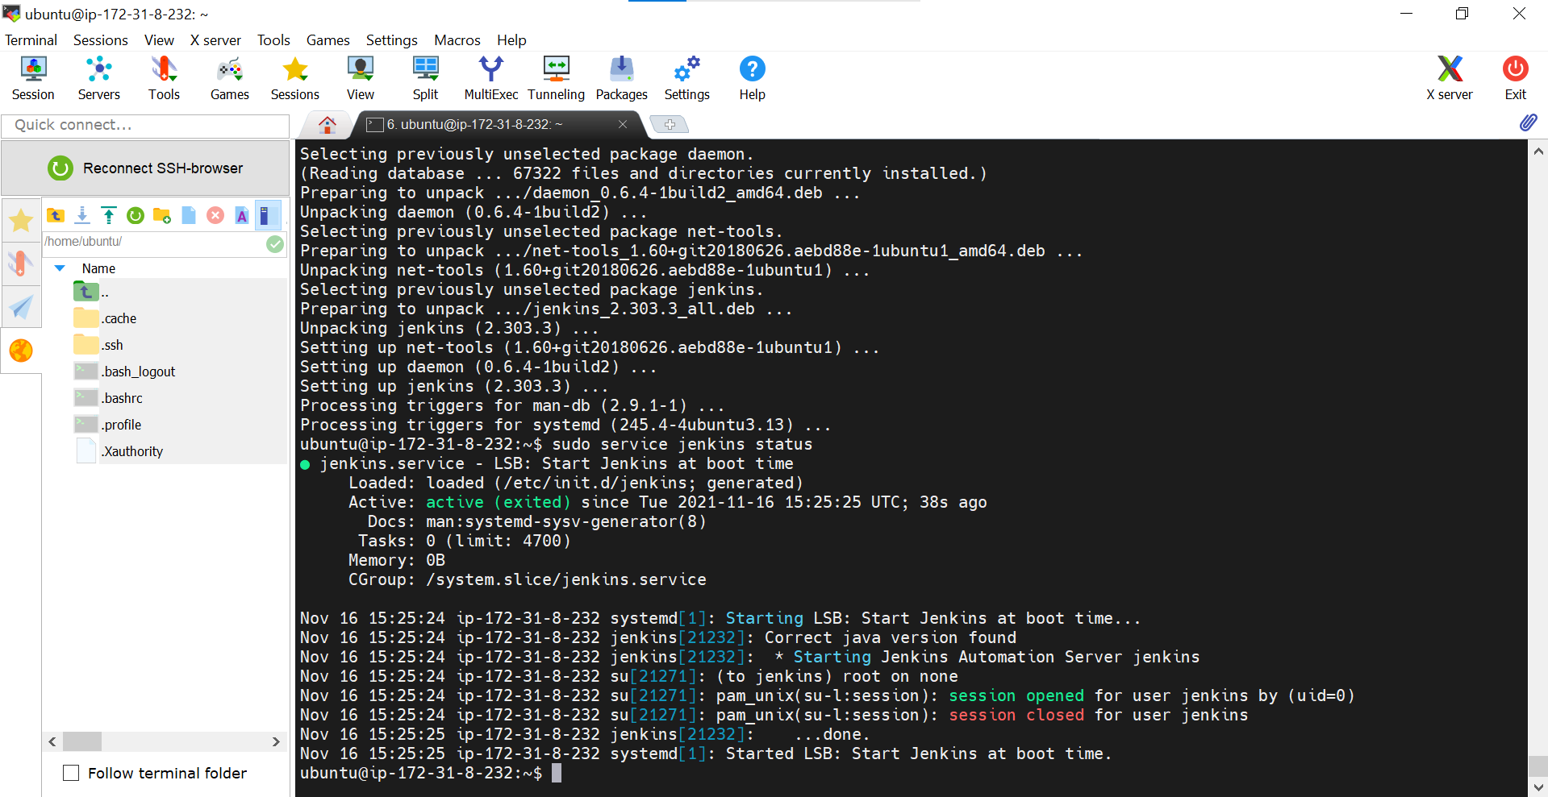

1. **Configure Jenkins**

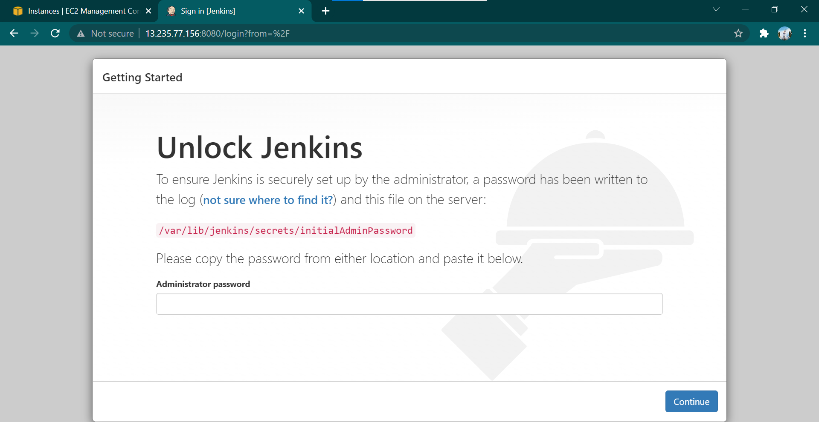

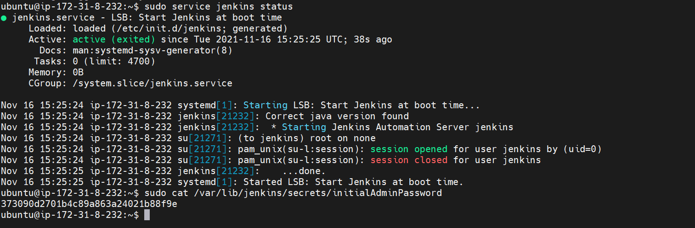

* Run http://13.235.77.156:8081/

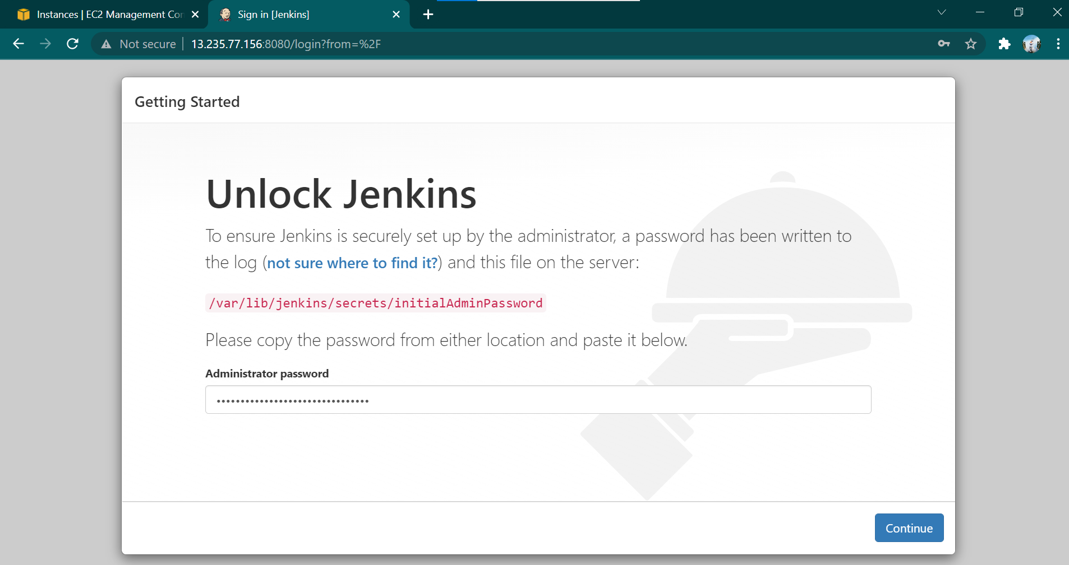

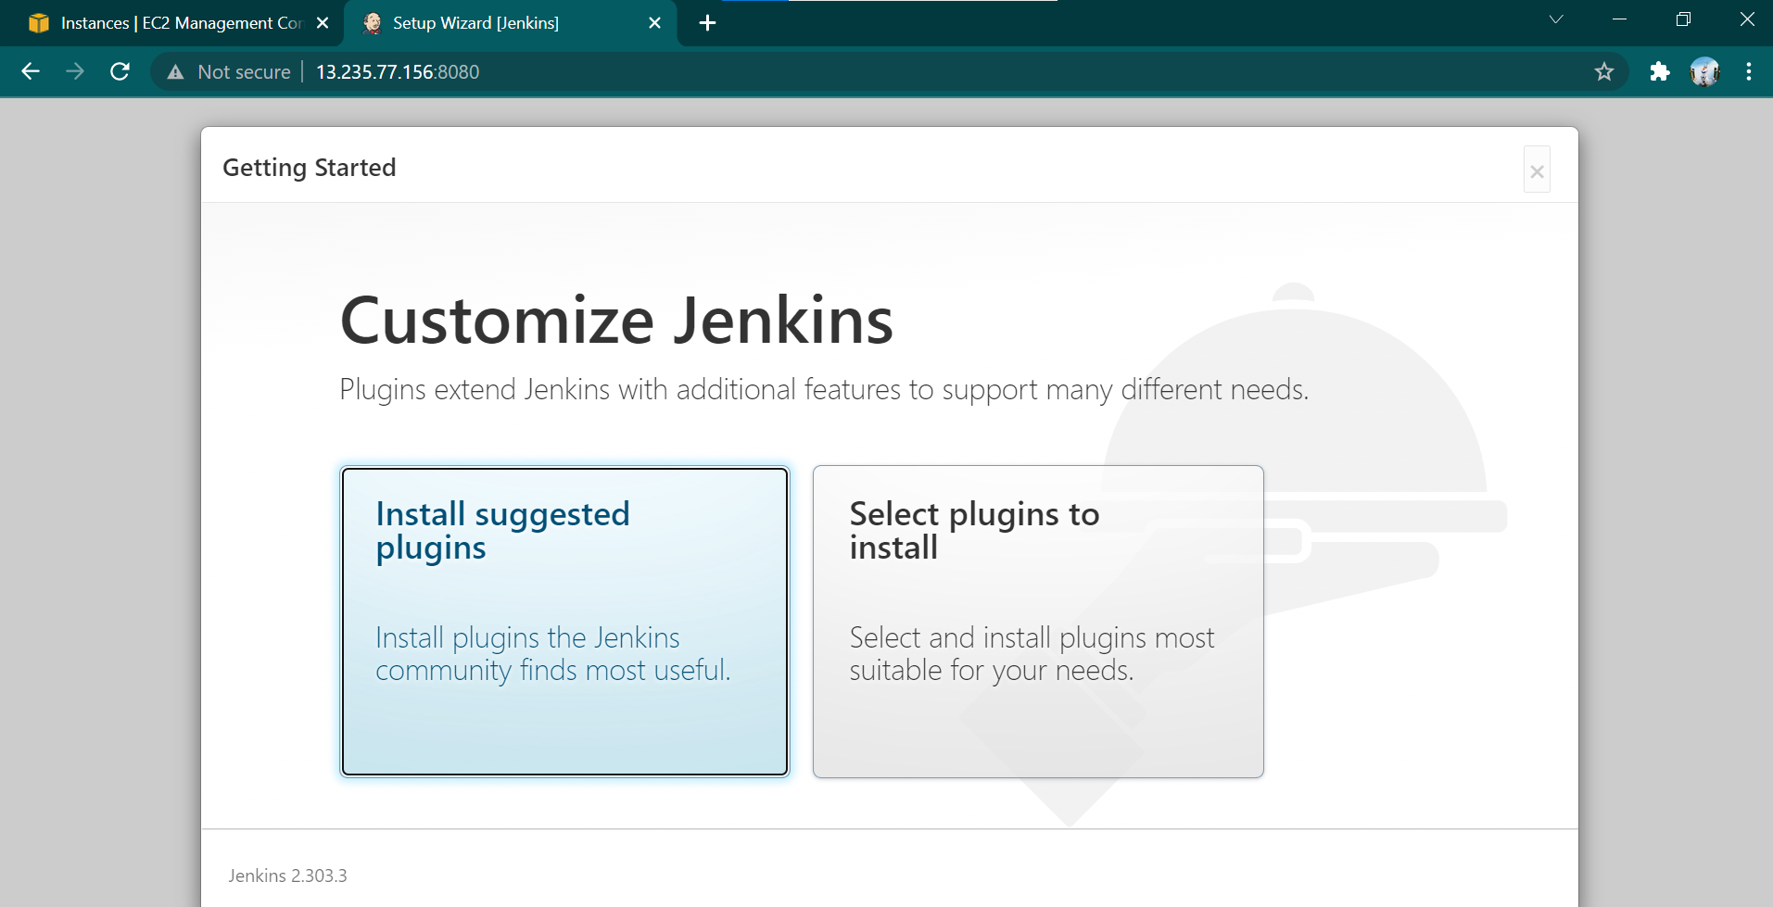

Password:admin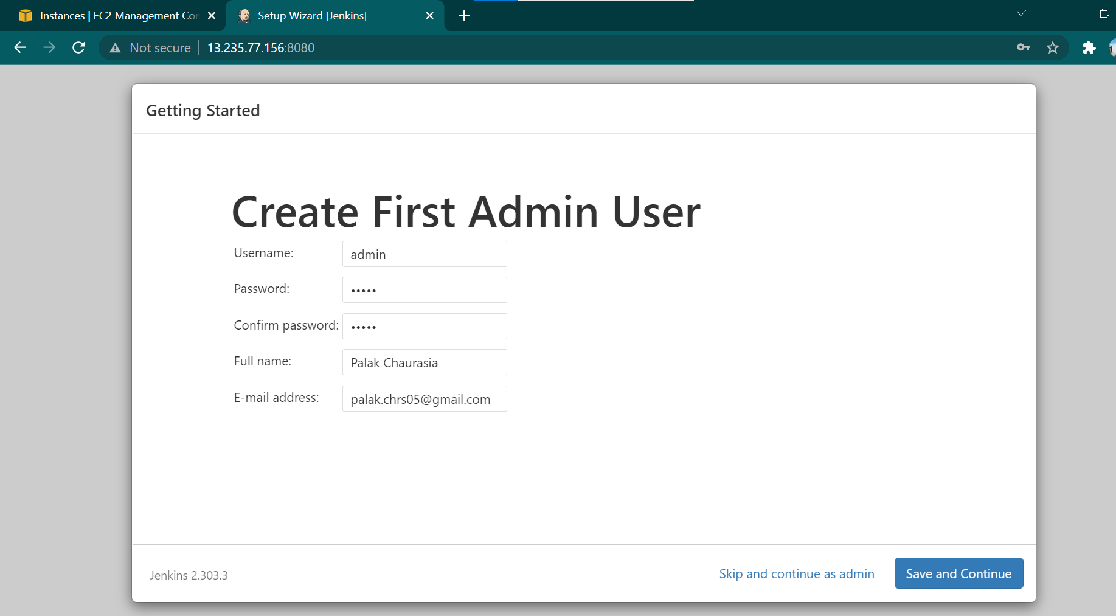

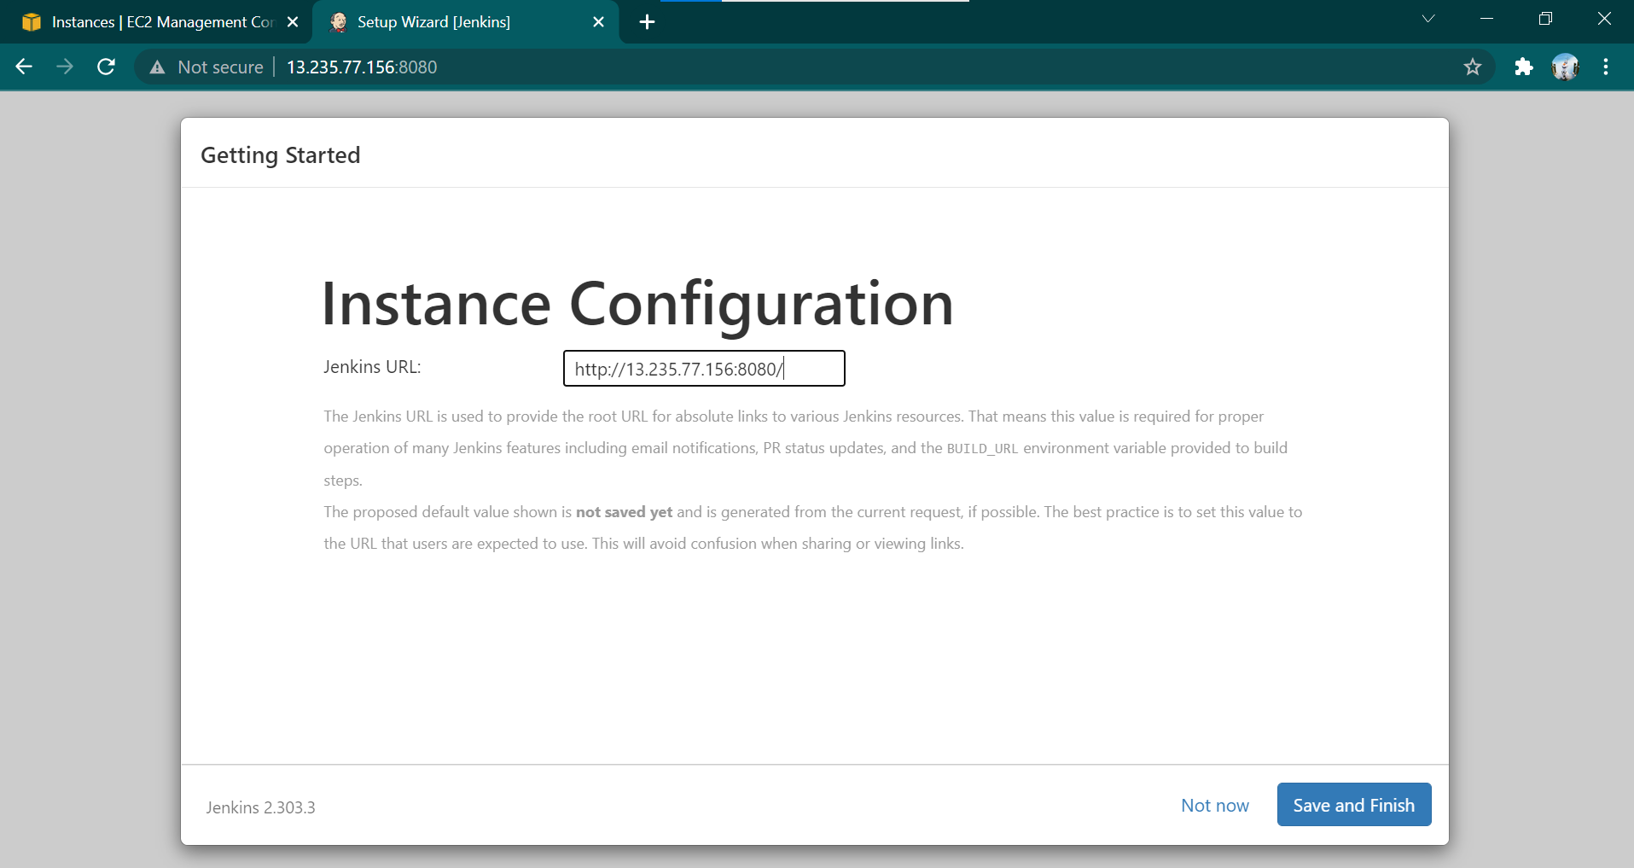

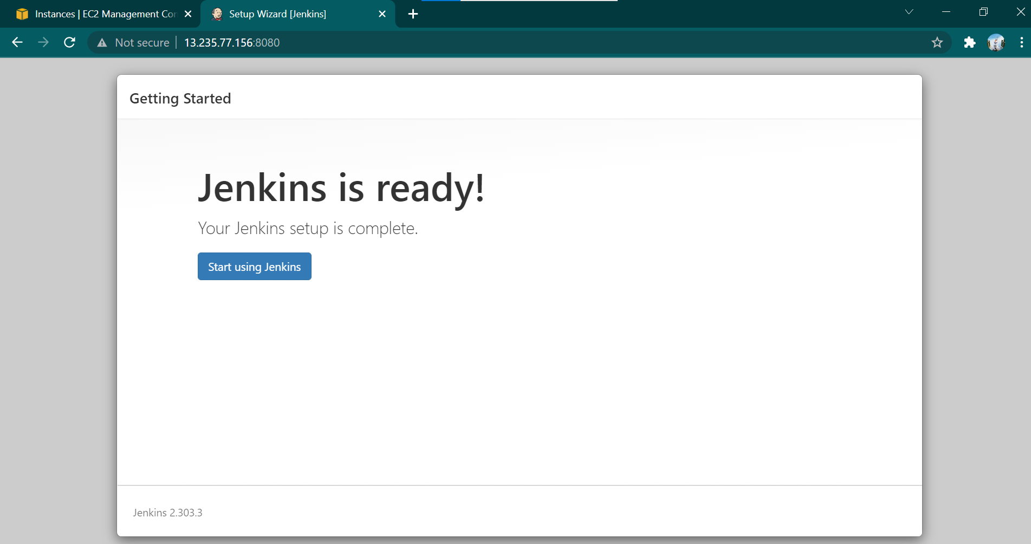

1. **Configure CI Pipeline**

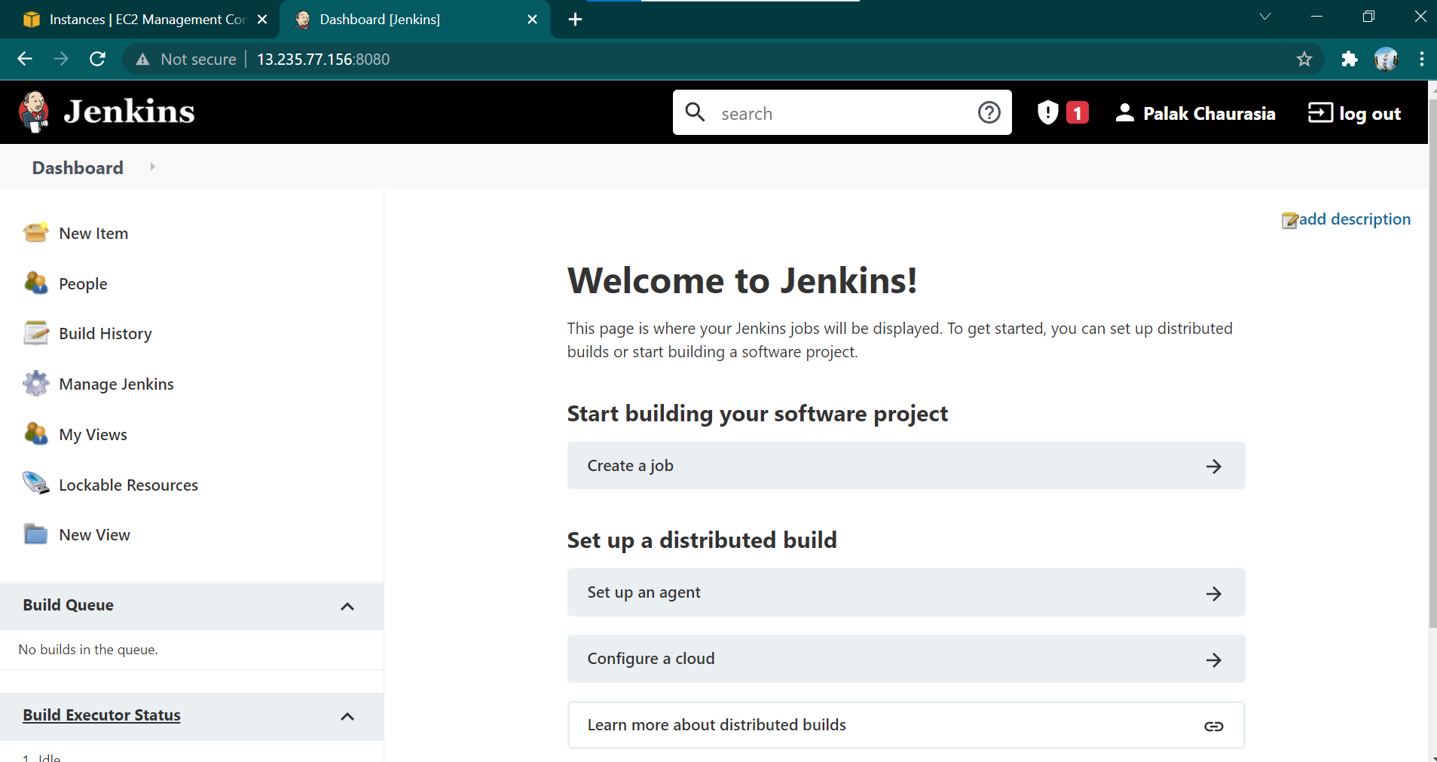

* Add new item: ecom-webservice pipeline

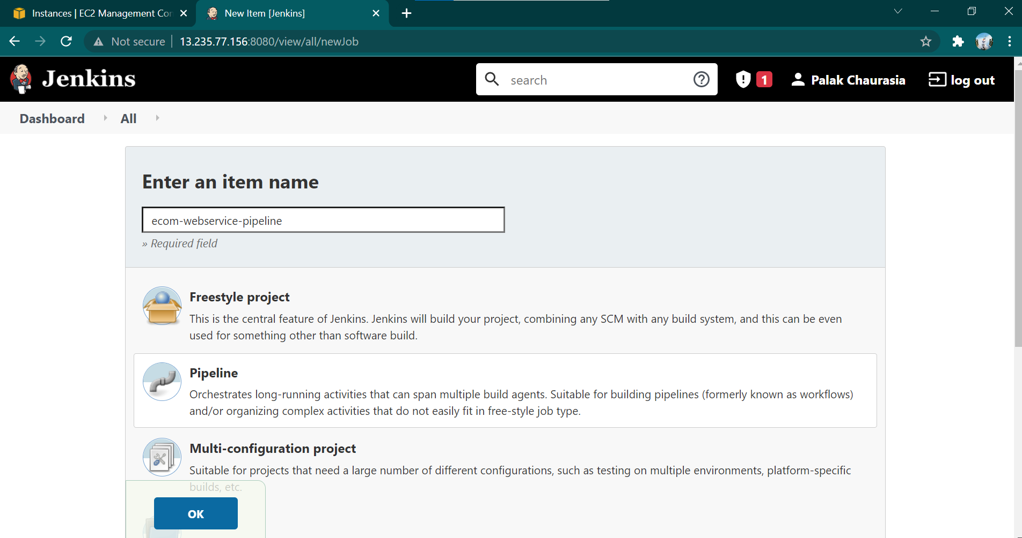

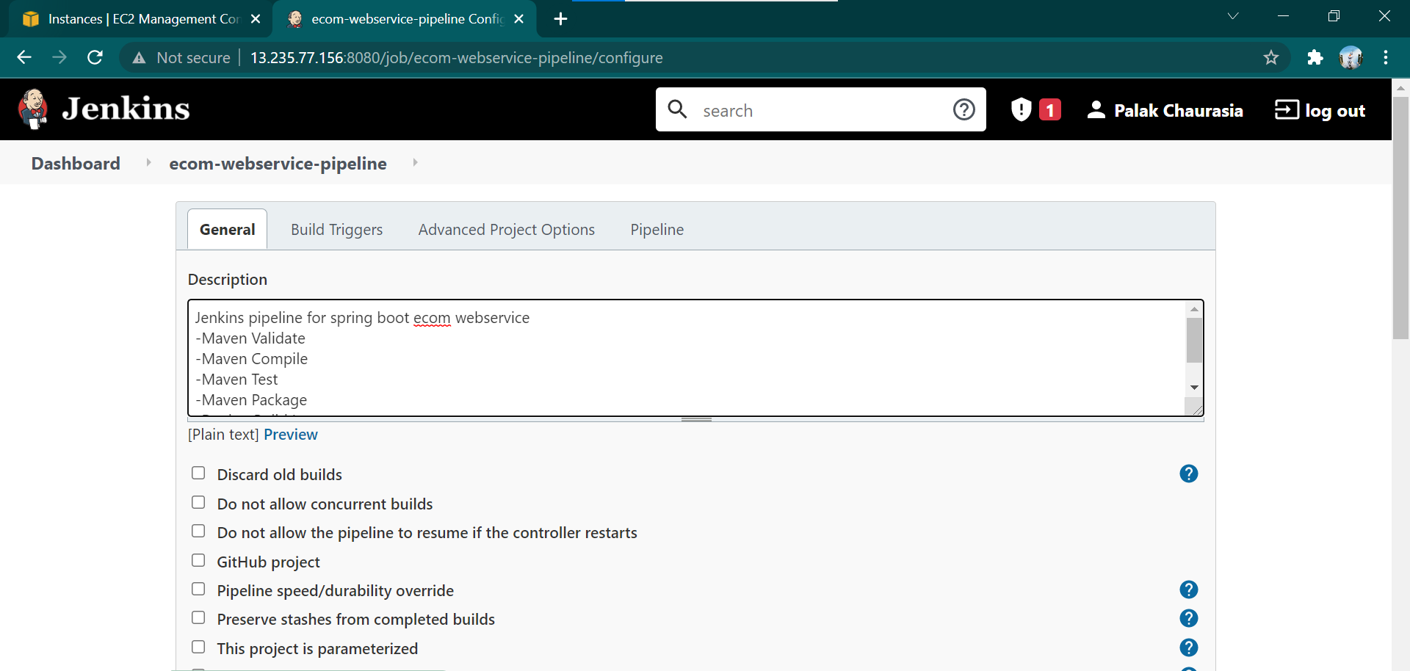

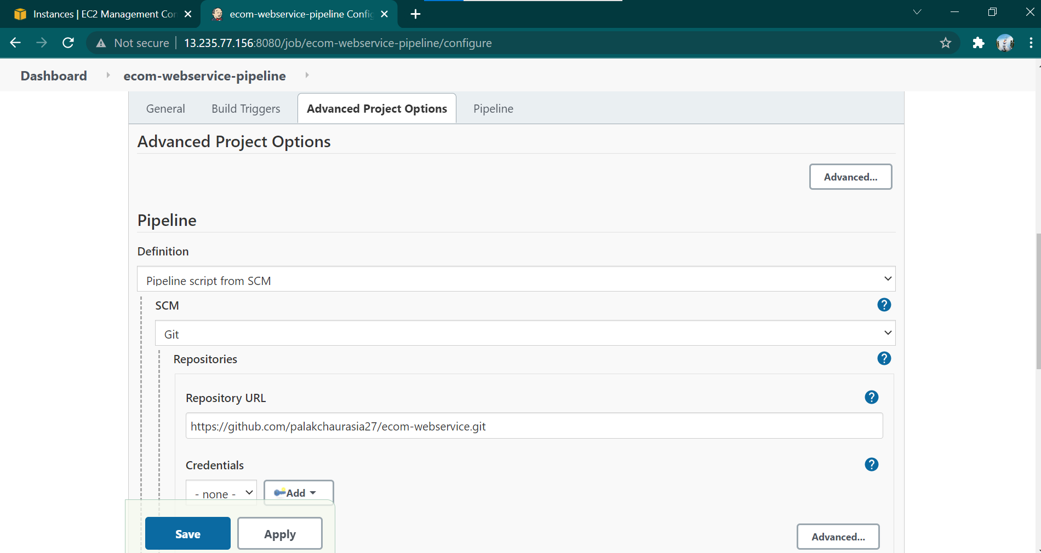

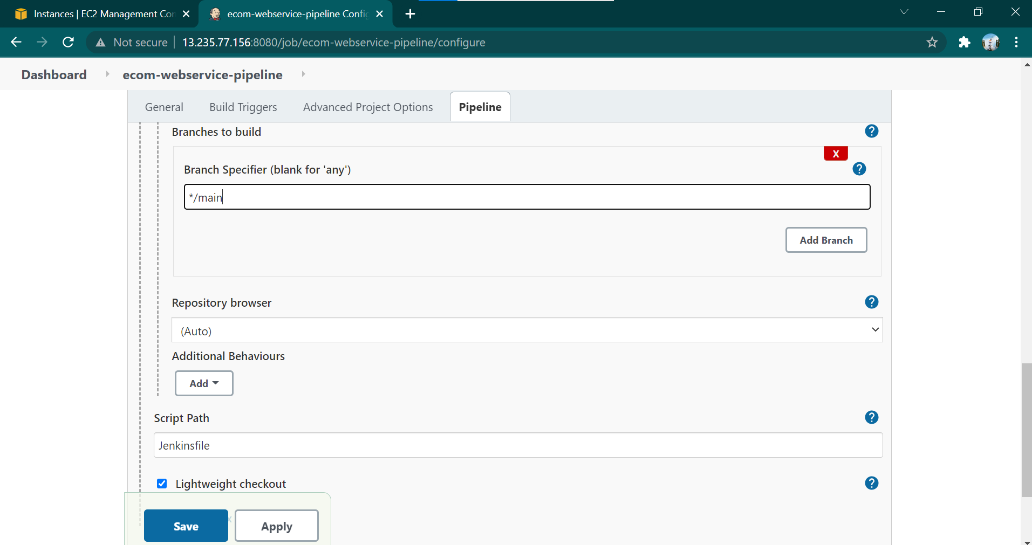

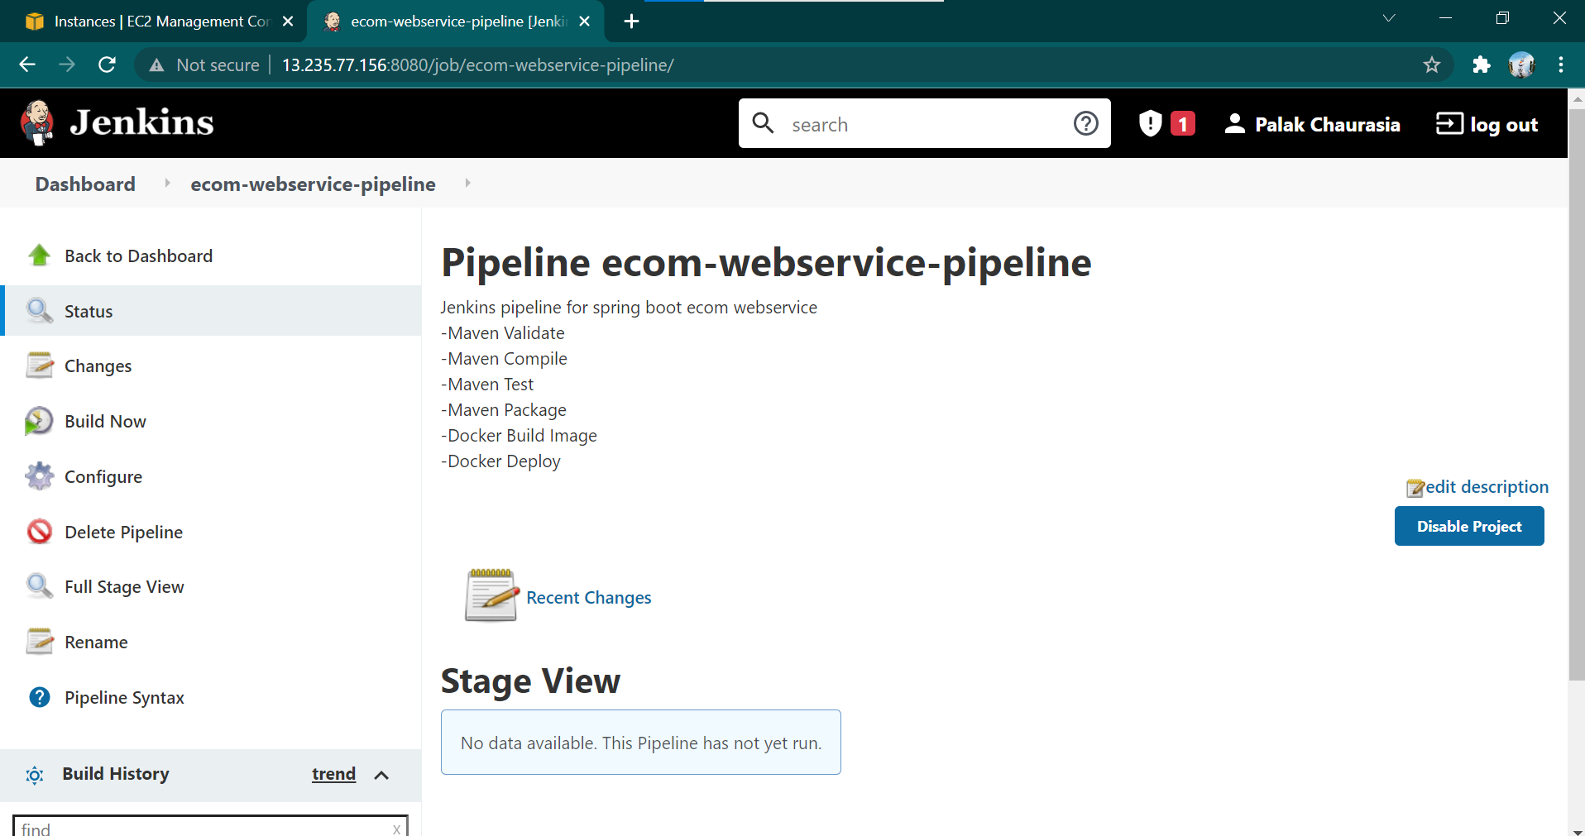

* Build Now

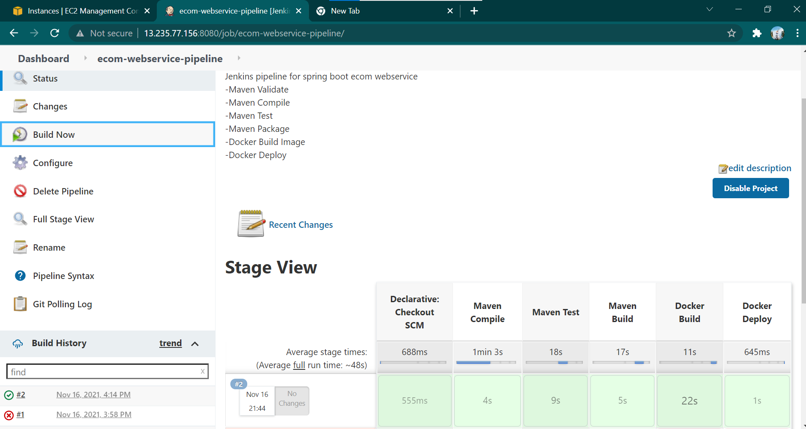

1. **Steps to Run**
2. Run <http://13.235.77.156:8081/>
3. Run <http://13.235.77.156:8081/greeting?name=Ravi%20Singh>
4. Run <http://13.235.77.156:8081/hello>
5. Run http://13.235.77.156:8081/employees/
6. https://github.com/palakchaurasia27/ecom-webservice.git
7. **Steps To Test**
   1. Run IP <http://13.235.77.156:8081/>

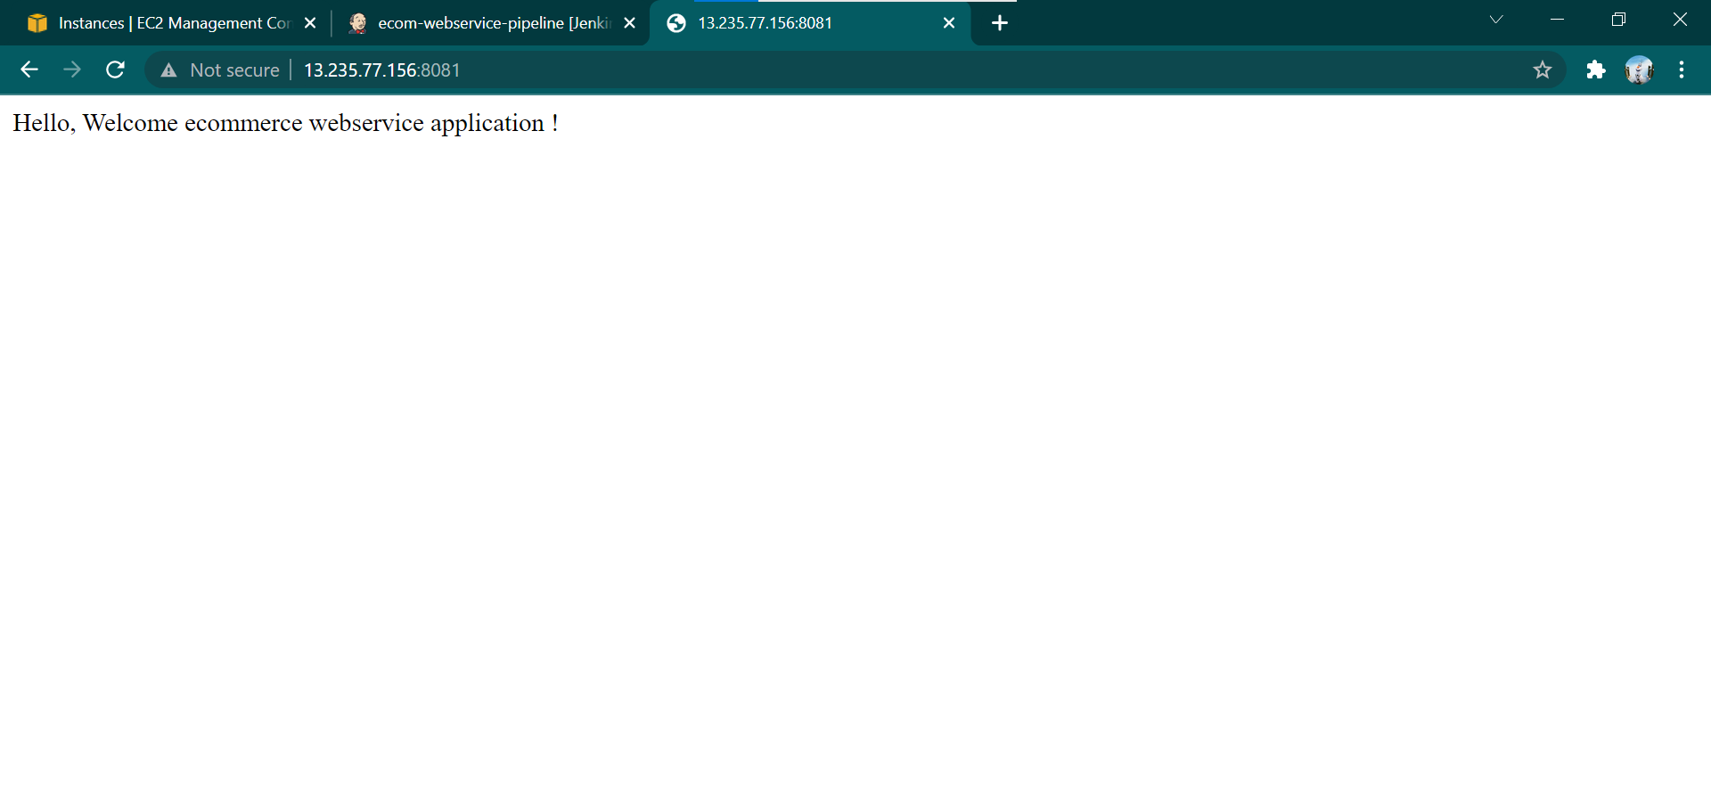

* 1. Run <http://13.235.77.156:8081/greeting?name=Ravi%20Singh>

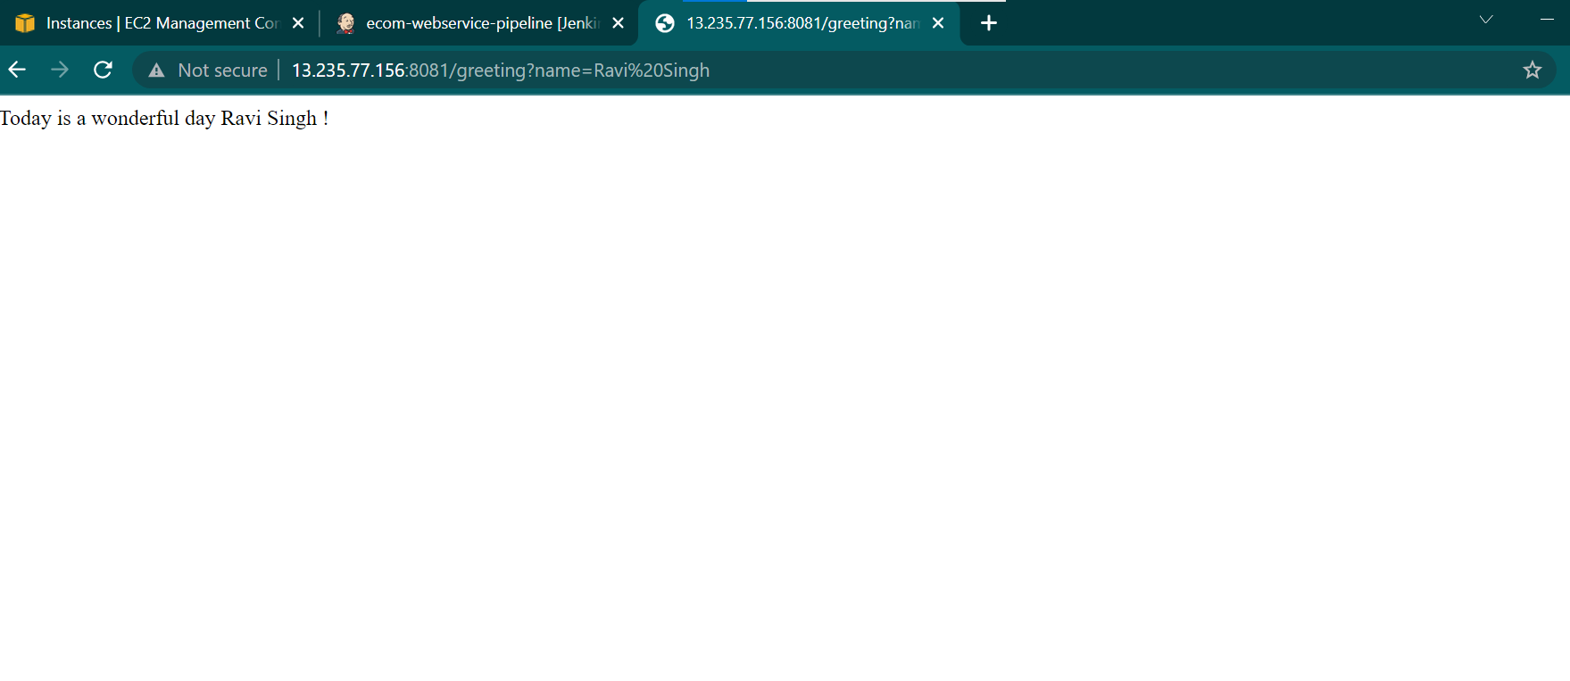

* 1. Run <http://13.235.77.156:8081/hello>

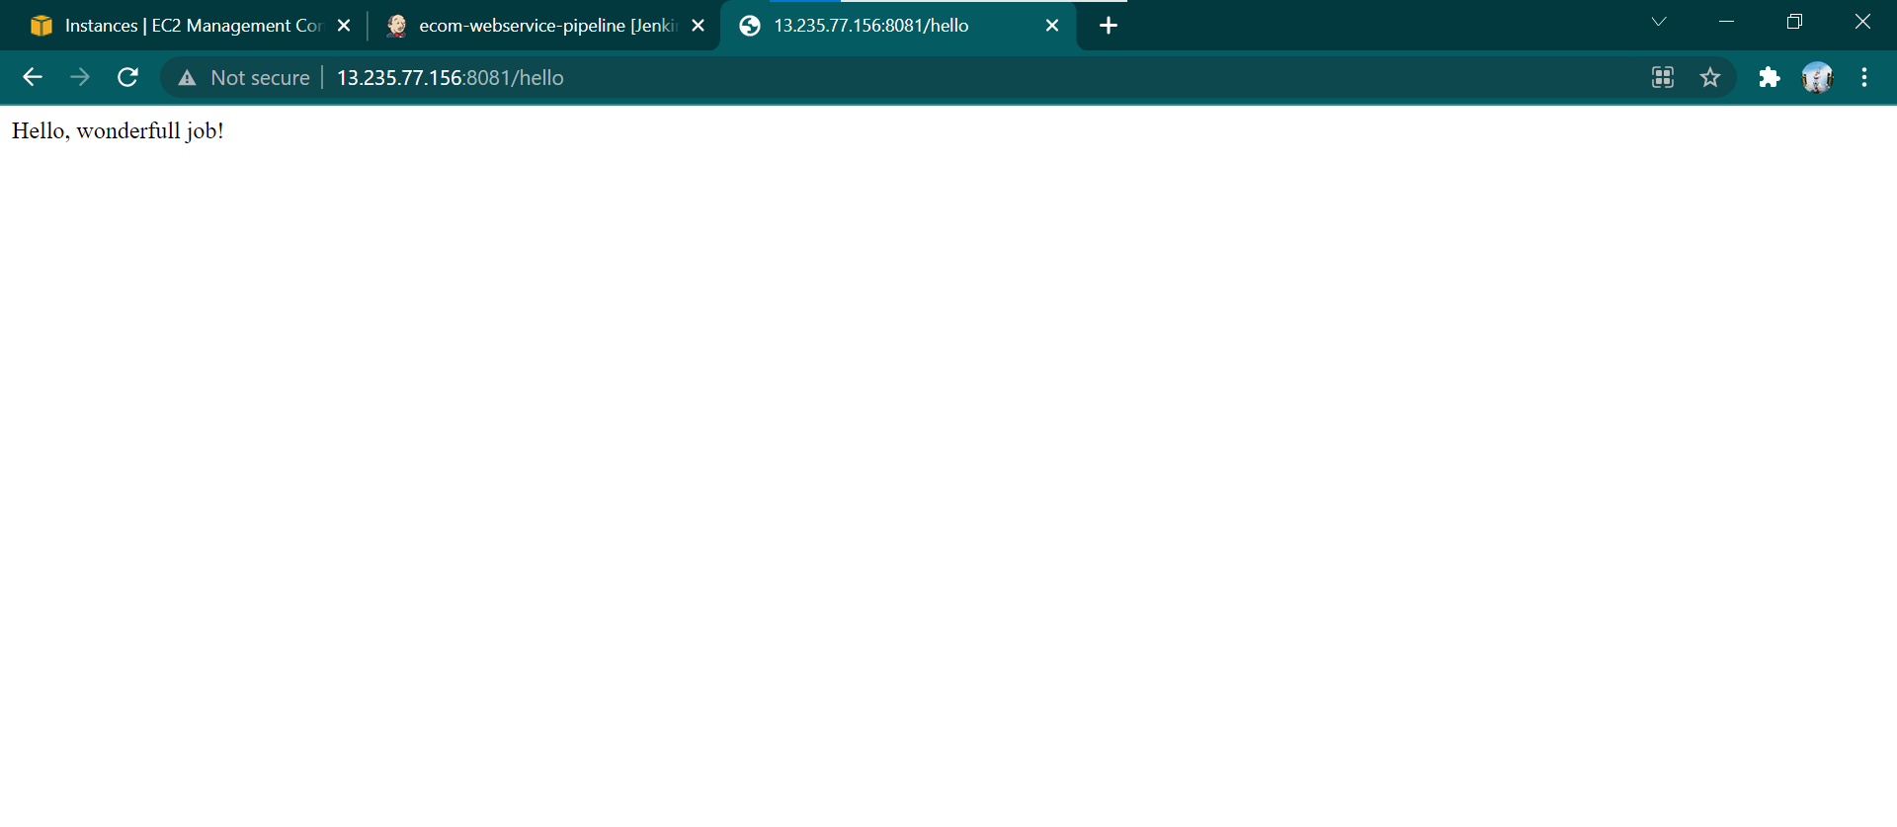

* 1. Run <http://13.235.77.156:8081/employees/>

